# Use Case 1: Identity Verification

The first package I used for identity verification was Amazon ReKognition. The ReKognition package had a slightly lower accuracy and recall than the open-sourced package “face_recognition.” This is interesting because Amazon has sold its face recognition package to government agencies for identity verification purposes. A likely cause of this was changing the similarity threshold within the recognition package to 60% instead of the default 50%. I wanted to have a stricter threshold for similarity to increase accuracy. Still, it seems that the 60% threshold within the package lowered the match similarity to exclude some headshots that could have been matched. An example of an expected match is my headshot. With ReKognition, the match similarity was 97.18%, and with the open-source face_recognition package, my match similarity was 60.72%. An example of an expected non-match would be Alicia Bodoia’s headshot. Her aged headshot is nearly unrecognizable. AWS recognition gave a match similarity of 0%, and the face_recognition package gave a match similarity of 20%.

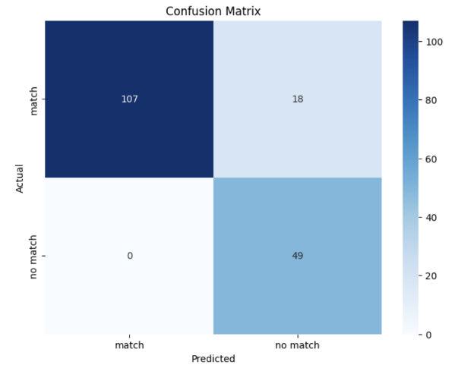**Confusion matrices**

**AWS Face_recognition**

**Tables of accuracy, precision, and recall**

|  |  |  |
| --- | --- | --- |
|  | **AWS ReKognition** | **facial_recognition** |
| **Accuracy** | 0.896551724137931 | 0.9022988505747126 |
| **Precision** | 1.0 | 0.9821428571428571 |
| **Recall** | 0.856 | 0.88 |

# Use Case 2: Attendance

This is where the AWS package shines, especially if the company aims to use facial recognition for pictures with multiple people. A lot of the matches from the face_recognition package are entirely incorrect. In image 1, for example, there are only two correct matches, and the other eight predictions are entirely wrong or match the aged pictures of people who are also incorrect. Although AWS ReKognition matched the aged headshots to half the people in image 1, they are the correct people and have a high match similarity. For example, Eric Mayo, Mary Martha Milcoff, and Kyle Wiblishauser are 99% matches. Another essential thing to note is that I was successfully matched despite wearing a hat. The match similarity was expectedly lower (~84%), but having the ability to accurately recognize faces through obstructions could be very valuable. Also, please recognize that both the aged and normal headshots are commonly matched to the attendance picture, which affects the number of matched faces counted.

**Face_Recognition:**

**AWS ReKognition:**

